**FOR IMMEDIATE RELEASE**

*Contact: Marcus Phillips*

*Phone: (415) 654-8569*

*Email:* [*marcus@intermusicsf.org*](mailto:marcus@intermusicsf.org)

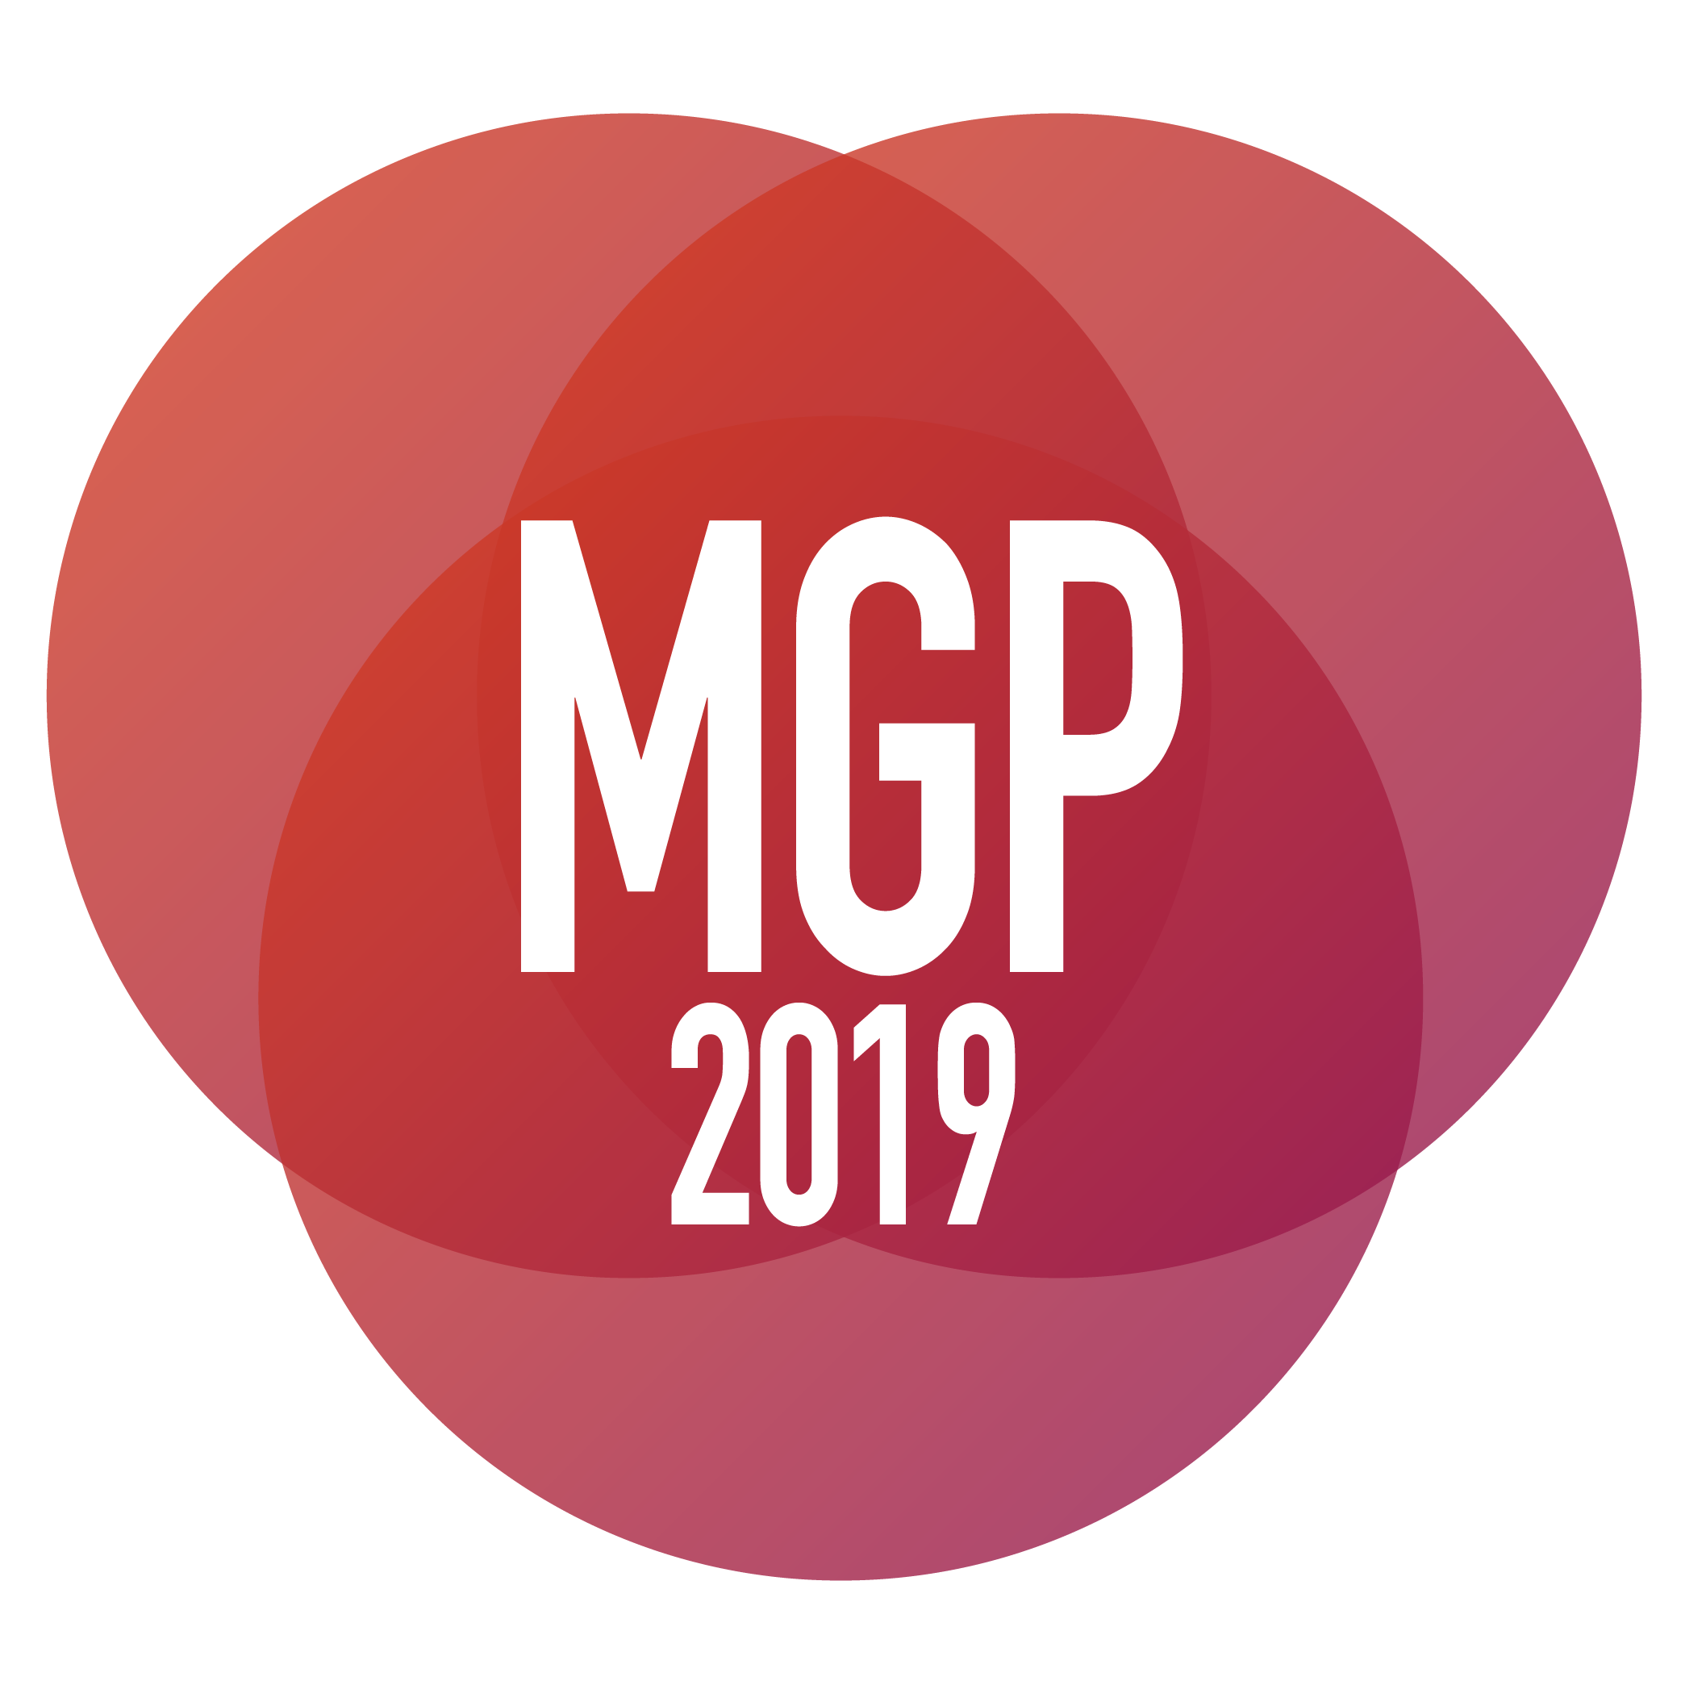

**INTERMUSIC SF ANNOUNCES**

**THE 2019 MUSICAL GRANT PROGRAM RECIPIENTS**

**&**

**THE RECIPIENT OF THE CYPRESS AWARD**

June 4th, 2019 - SAN FRANCISCO— InterMusic SF proudly announces the **21 recipients** of this year's **Musical Grant Program**, as well as the **2** recipients of the returning ***Cypress Award***, an additional award given to a deserving musical project that strives to make an educational impact throughout the Greater Bay Area. The Musical Grant Program (MGP) is a funding initiative designed to support outstanding projects of early music, chamber music, new music, jazz, and creative music in the greater San Francisco Bay Area.

The MGP awards grants through a competitive process to projects that showcase the artistry of local ensembles and enhance the careers of professional musicians. The program aims to foster excellence in the Bay Area’s diverse musical community while cultivating greater access and genuine engagement for new and existing audiences.

The returning Cypress Award is made possible through a generous donation from the recently-retired [Cypress String Quartet](http://cypressquartet.com/). Seeking to celebrate artistic excellence and educational innovation across musical genres, the Cypress Award provides an additional grant to an MGP awardee that includes an innovative educational project.

Every year, applications are accepted from both emerging and established organizations with budgets below $150,000, including professional small ensembles, composers with collaborating ensembles, and presenting organizations. The MGP is one of a very small number of grants available to this community, and as such plays a crucial role in maintaining cultural opportunities for the public. Now in its 11th cycle, the MGP has proven an extraordinary resource in contributing to the variety and breadth of Northern California’s musical landscape.

In May 2019, the Musical Grant Program awarded grants of up to $4,000 to 21 ensembles, composers, and presenters. The projects described below tell the story of the tremendous diversity and creativity within San Francisco Bay Area's musical community.  **We extend our deepest gratitude to the** [**San Francisco Grants for the Arts**](http://sfgfta.org/), the [**Clarence E. Heller Charitable Foundation**](http://www.cehcf.org/), the [**William and Flora Hewlett Foundation**](https://www.hewlett.org/)**,** and **our many donors** for their generosity. In the past eleven cycles since 2008, InterMusic SF (formerly San Francisco Friends of Chamber Music) has awarded over $815,000 to help support 276 musical projects in the greater Bay Area.

**2019 Cypress Award:**

***Mads Tolling and Brass Over Bridges***

*The 2019 Cypress Award goes to two MGP Awardees to support educational outreach through their MGP awarded projects.*  
  
**Mads Tolling** – Will create a set of tailored outreach performances for Bay Area middle and high school students that will focus on compositions incorporating non-traditional techniques and musical structures. By using the music of Broadway’s acclaimed “Hamilton the Musical” as a reference, Tolling looks to bridge classical and popular music to help make music more accessible for all.

Tolling will also create a series of workshops for Bay Area universities that will focus on the process of making music that crosses and blurs cultural boundaries. With a focus on improvising on orchestral instruments Tolling hopes to inspire a new wave of musicians that are excited to explore new styles of music.

**Brass Over Bridges** – Will create a special performance program for Bay Area schools that aims to demystify the process of composing music. With the assistance of Bay Area composer [Julie Barwick](https://www.juliebarwick.com/), Brass Over Bridges will teach students the process of how an idea can become a melody and evolve into a composition. Together the students and the quintet will collectively compose and perform a short piece including handheld instruments supplied by the ensemble.

**2019’s MGP Awardees:**

*(List of Ensembles with genres)*

**Ars Minerva –** *Early Music, Opera.*

[Ars Minerva](https://www.arsminerva.org/) will produce Ermelinda, an opera composed by Domenico Freschi in 1680 with libretto by Francesco Maria Piccioli, which has never been performed since its creation at Teatro delle Vergini near Venice. The “*Modern World Premiere*” will take place November 2019 at [ODC Theater](https://odc.dance/).

**The Berkeley Festival of Choro –** *Brazilian, Festival.*

[Berkeley Festival of Choro](http://www.berkeleychoro.com/) will promote, produce and record its annual festival at St. John’s Presbyterian Church, Berkeley in October 2019.

**Brass Over Bridges / Julie Barwick –** *Classical Music, New Music, Commission.*

[Brass Over Bridges](https://www.brassoverbridges.com/) will commission composer [Julie Barwick](https://www.juliebarwick.com/) for a new work, inspired by Bay Area poetry and poets, drawing from the diverse literary communities of the Bay Area. The piece will be premiered on a Brass Over Bridges concert of music by female composers in San Francisco, in the spring of 2020.

**The Chromelodia Project / Chris Brown –** *Experimental, New Music, Commission, Recording.*

Composer/performer [Chris Brown](http://cbmuse.com/) will compose & record a new piece for his ensemble, **The Chromelodia Project** (with [Theresa Wong](https://www.theresawong.org/) and [Kyle Bruckmann](http://kylebruckmann.com/)) exploring just intonation, improvisation, and interactive computer music. The new work will at the [Center for New Music](https://centerfornewmusic.com/) in San Francisco.

**Ensemble ARI / Jean Ahn –** *New Music, Classical Music, Commission.*

[Ensemble ARI](http://jeanahn.com/ensemble-ari/) will commission [Jean Ahn](http://jeanahn.com/) to write a new piano quartet to premiere on their *Women Composers* concert, January, 2022 at St. Mary’s College, Moraga. The Commission initiates the ensemble’s “*piano quartet library project*,” enriching the repertoire of contemporary music for piano quartet.

**Ensemble for These Times / Elinor Armer –** *New Music, Classical, Commission.*

[Ensemble for These Times](http://www.e4tt.org/) will commission and premiere “*Matrix*” by Bay Area composer [Elinor Armer](http://www.elinorarmer.com/) for soprano and piano, setting texts by two Bay Area poets, Ursula K. LeGuin and Rella Lossy. The new work will premiere as part of the concert-program “*Mothers, Daughters, and Families,*” a musical exploration of inter-generational issues affecting women.

**The Frank Tusa Ensemble –** *Jazz, Recording*

[Frank Tusa](http://franktusa.com/) will write and record eight new compositions within diverse jazz combos, from duos with flute, to sextet including tabla.

**Friction Quartet / Danny Clay –** *New Music, Commission*

[Friction Quartet](https://www.frictionquartet.com/) will commission [Danny Clay](https://www.dclaymusic.com/) and present a new educational concert developed to be engaging and inclusive of youth with cognitive, behavioral, and physical differences. The new work, to be premiered at the [Pomeroy Recreation and Rehabilitation Center](https://www.prrcsf.org/) in San Francisco, will involve audience participation and will be designed to be accessible for all levels of ability.

**L'arc Trio / Vivan Fung –** *Classical Music, New Music, Commission.*

[L'arc Trio](https://www.barbarafritzchambermusicaward.org/2018-winner) will commission [Vivian Fung](http://vivianfung.ca/) as part of the program, “*Beethoven 250*,” a concert celebrating the legacy of Beethoven’s piano trios for his 250th anniversary year. L’arc Trio will perform two Beethoven piano trios alongside the premiere of Fung’s commissioned work, “inspired by Beethoven’s indomitable spirit.”

**Mads Tolling / The Mads Men –** *Jazz, Commission*

[Mads Tolling](http://madstolling.com/) will compose a four-movement piece for his band, [The Mads Men](http://madstolling.com/mads-men/), inspired by Danish philosopher Søren Kierkegaard’s masterpiece "*Either/Or*," with rapping, singing and spoken word in English and Danish by special guests and Mads Tolling. The premiere performance will take place at The Freight & Salvage and in October 2020.

**The MANA Quartet / Common Sense Composers' Collective –** *New Music, Recording*

[MANA Quartet](https://themanaquartet.com/) will premiere and record 8 new compositions with the eight-member [Common Sense Composers’ Collective](http://www.commonsensecomposers.org/).

**MediusTerra Horn Duo / Aida Shirazi –** *New Music, Classical Music, Commission.*

[MediusTerra Horn Duo](http://www.mediusterramusic.com/) will commission and premiere “*Songs of Dionysus*,” a new work by Davis-based Iranian composer [Aida Shirazi](http://aidashirazi.com/) juxtaposing unexplored nuances in Iranian classical music with modern French Horns and electronics. The premiere performance will will take place in the spring of 2021.

**Melody of China –** *Chinese, Persian, Commission*

[Melody of China](https://melodyofchina.org/) will present a concert with [Nejad World Music Center](http://www.nejadmusic.com/) as part of the 2020 San Francisco International Arts Festival in June 2020. Collaborating with [Mohammed Nejad](http://www.nejadmusic.com/nejad.html) and guest musicians, the program will feature new arrangements of traditional Chinese and Persian melodies as well as an experimental new work for Chinese/Persian mixed ensemble.

**New Moon Duo / Nicolas Lell Benavides –** *New Music, Commission*

[New Moon Duo](https://www.newmoonduo.com/)- pianist [Anne Rainwater](http://annerainwater.com/) and mezzo-soprano [Melinda Becker](https://www.melindabecker.com/) will commission composer [Nicolas Lell Benavides](https://www.nickbenavides.com/) to write a new song cycle exploring the unique cultural identity of New Mexicans. The songs will be sung in *Caló*a dialect of Spanish spoken first by Chicano communities in New Mexico and Texas along the U.S.-Mexico border, and later spreading to Los Angeles and the Bay Area.

**Outsound Presents: Outsound New Music Summit –** *New Music, Festival*

[Outsound Presents](http://www.outsound.org/) will host its 18th Annual [Outsound New Music Summit](http://www.outsound.org/summit/), July, 2019 at the [Community Music Center](https://sfcmc.org/) in San Francisco. The Summit will feature six nights of performances showcasing new musical works and improvisations by local artists and national guests, showcasing the world premiere of *Tomography Fortunae*, by Polly Moller Springhorn; the collaboration of [Francis Wong](http://www.franciswong.net/) and dancer [Lenora Lee](http://www.lenoraleedance.com/); and percussionist duo, [William Winant](https://williamwinant.com/) and improviser [Zachary James Watkins](http://www.zacharyjameswatkins.com/).

**Quinteto Latino –** *Classical Music, New Music, Latin American, Recording*

[Quinteto Latino](http://quintetolatino.org/) will produce studio-recorded videos of Waldir Azevedo’s “*Brasileirinho*” and Astor Piazzolla’s “*Libertango*,” two short works central to their core concert repertoire, both arranged by composer [Mark Fish](https://www.markfish.com/).

**Rent Romus / Heikki Koskinen –** *Jazz, World Music, Commission*

[Rent Romus](http://www.romus.net/) will record a new project, co-written with [Heikki Koskinen](http://www.heikkikoskinen.com/) entitled “*Manala*” (netherworld), for Romus’ nonet, [Life’s Blood Ensemble](http://romus.net/lifesblood.html). The project weaves elements of jazz, traditional folk, and free improvisation, inspired by the mythic prose of cultural liberation and identity in the Finnish national epic, *the Kalevala,*and the folklore of northern arctic traditions.

**Splinter Reeds / Amadeus Regucera –** *New Music, Experimental Music, Commission*

[Splinter Reeds](http://www.splinterreeds.com/) will commission composer [Amadeus Regucera](http://amadeusregucera.com/) to compose “*With|Against*,” a new multimedia work highlighting the reed quintet’s virtuosity and engaging in interdisciplinary practices including video, light, and spatialized movement in an exploration of uncommon audience engagement and participation. The premiere will be presented by [Indexical](https://www.indexical.org/), an experimental music nonprofit in Santa Cruz, at [Radius Gallery](http://www.radius.gallery/) in early June 2020.

**Teslim –** *Contemporary Modal, Commission, Recording*

[Teslim](http://www.kailaflexer.com/teslim/) will produce “*7 Decades*,” a recording of compositions by [Kaila Flexer](http://www.kailaflexer.com/), inspired by by Turkish, Greek and Sephardic folk music as well as blues, jazz & western classical chamber music.

**Hyo-shin Na / Wooden Fish Ensemble –** *Classical Music, New Music, Japanese, Korean, Commission*

[Wooden Fish Ensemble](http://www.hyo-shinna.com/html/wooden_fish_ensemble.html) will present a program of [Hyo-shin Na](http://www.hyo-shinna.com/)'s music for Japanese, Korean, and western instruments at [Old First Concerts](https://www.oldfirstconcerts.org/) on October 27, 2019. Four new works will be commissioned and premiered, along with three of her older works.

**ZOFO / Pablo Ortiz –** *New Music, Commission*

[ZOFO](https://www.zofoduet.com/) will commission Argentine American composer [Pablo Ortiz](https://arts.ucdavis.edu/faculty-profile/pablo-ortiz-0) for a piano duet concerto with two versions, one with string orchestra, and the second with string quintet, premiering in 2020. The pianists will sit on *cajónes*, changing quickly between playing the Latin-American box percussion instruments and the keyboard.

### END###

Link to Press Photos: <http://www.intermusicsf.org/press-room>

For more information on the 2019 MGP please contact [marcus@intermusicsf.org](mailto:marcus@intermusicsf.org)