FOR IMMEDIATE RELEASE
Contact: Marcus Phillips
Phone: (415) 654-8569
Email: marcus@intermusicsf.org
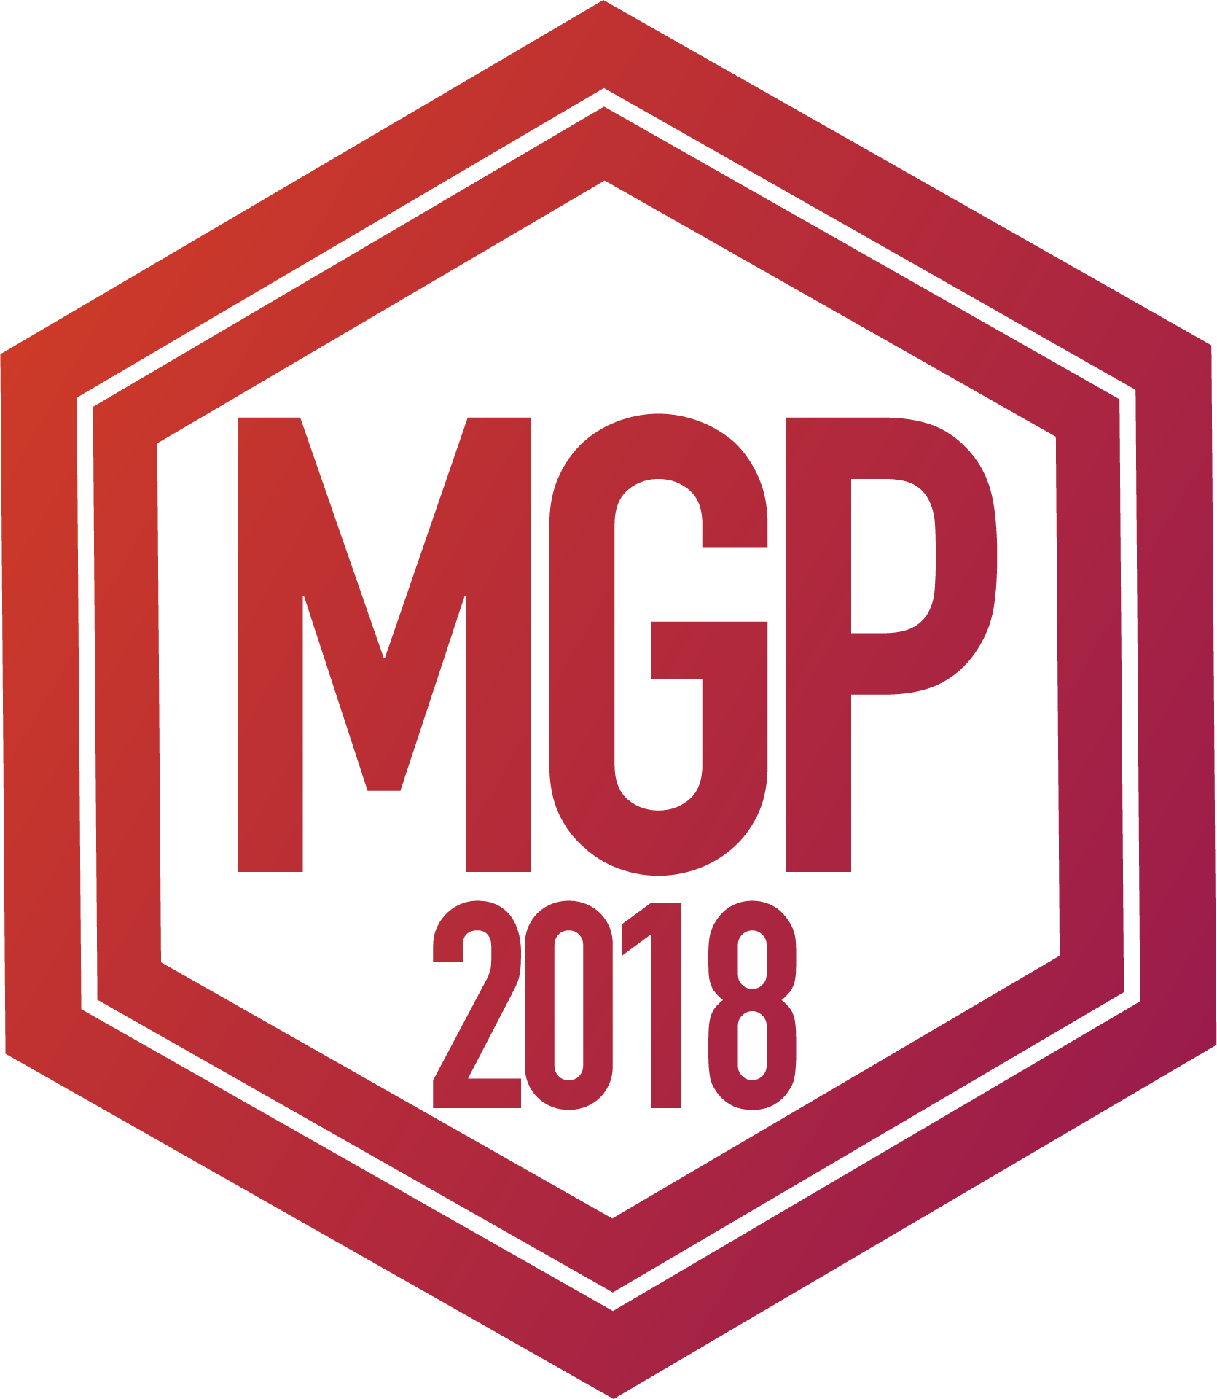

INTERMUSIC SF ANNOUNCES
THE MUSICAL GRANT PROGRAM AWARDEES OF 2018
&
THE RECIPIENT OF THE FIRST CYPRESS AWARD

May 29th, 2017 - SAN FRANCISCO— InterMusic SF proudly announces the 22 awardees of this year's Musical Grant Program, as well as the recipient of the first Cypress Award, a special award given to a deserving musical project that strives to make an educational impact throughout the Greater Bay Area. The Musical Grant Program (MGP) is a funding initiative designed to support outstanding projects of early music, chamber music, new music, jazz, and creative music in the greater San Francisco Bay Area.

The MGP awards grants through a competitive process to projects that showcase the artistry of local ensembles and enhance the careers of professional musicians. The program aims to foster excellence in the Bay Area’s diverse musical community while cultivating greater access and genuine engagement for new and existing audiences.

The new Cypress Award is made possible through a generous donation from the recently-retired Cypress String Quartet. Seeking to celebrate artistic excellence and educational innovation across musical genres, the Cypress Award provides an additional grant to an MGP awardee that includes an innovative educational project.

Every year, applications are accepted from both emerging and established organizations with budgets below $100,000, including professional small ensembles, composers with collaborating ensembles, and presenting organizations. The MGP is one of a very small number of grants available to this community, and as such plays a crucial role in maintaining cultural opportunities for the public. Now in its 10th cycle, the MGP has proven an extraordinary resource in contributing to the variety and breadth of Northern California’s musical landscape.

In May 2018, the Musical Grant Program awarded grants of up to $4,000 to 22 ensembles, composers, and presenters. The projects described below tell the story of the tremendous diversity and creativity within San Francisco Bay Area's musical community. We extend our deepest gratitude to the San Francisco Grants for the Arts, the Clarence E. Heller Charitable Foundation, the William and Flora Hewlett Foundation, and our many donors for their generosity. In the past nine cycles since 2008, InterMusic SF (formerly San Francisco Friends of Chamber Music) has awarded $668,000 to help support 234 musical projects in the greater Bay Area.

2018 Cypress Award:

Amaranth Quartet
In early Fall, 2018, Amaranth Quartet and D. Riley Nicholson will invite young composers (age 16-24) to submit works for consideration for a valuable workshop experience and performance on their concert program, “Bend, Bent, Break.” Four finalists will be chosen to participate in readings of works, composition lessons, and a workshop with Amaranth Quartet and Nicholson. Revised final versions of the four quartets will then be recorded and performed in a final session with Amaranth Quartet. Among the four finalist, one will be selected to be performed in May 2019 as part of the “Bend, Bent, Break” concert program. The winning composer will be given a $500 cash prize.

2018’s MGP Awardees:
(List of Ensembles by Genre)

Classical & New Music

African American Composer Initiative to commission composer Joshua McGhee and present their 10th anniversary concerts at at the Performing Arts Center of Eastside College Preparatory School, East Palo Alto in January 2019 presenting the rich heritage of music by African American men and women of the the past and present.

Richard Aldag and Vinifera Trio, for production costs to complete a CD of chamber music by Richard Aldag on Albany Records in Fall 2018.

Ted Allen to compose and perform “Death Is Reincarnated in Every Flower,” a new work for his ensemble, The Incendiary Cycle. The piece will include spoken word poems by six California-based poets, including two young writers recently recognized by the Oakland Youth Poet Laureate program. To be premiered in the fall of 2019.

Amaranth Quartet to commission “Break,” a new work by D. Riley Nicholson premiering at the Center for New Music and Arc Gallery in May of 2019. The program, Bend, Bent, Break, will include Philip Glass’s string quartet Benta and new work by an emerging Bay Area young composer (16-24) chosen through a call for scores and workshop process.

The Dirty Snacks Ensemble to record and release the second full length record of original compositions by ensemble leader Mark Clifford.

Bassist Sascha Jacobsen with Trio Garufa to compose Contra un Bajo de Magia accompanied by a short narrative film, directed by Neeti Fidurko, and Argentine Tango dancer, Andrea Fuchilieri. The premier performance will take place at the CELLSpace in the fall of 2019.

Anna Maria Mendieta’s Tango Del Cielo to complete their debut album The Harp-Tango Project recorded at Skywalker Ranch and support CD release concerts in Summer 2018.

Nash Baroque to present two performances of Baroque music and dance in collaboration with Jennifer Meller and the San Francisco Renaissance Dancers, exploring the influence of 18th-century French dance forms on the music of J.S. Bach.

Nomad Session to commission two new wind octet pieces from composers Emily Shisko and Mario Godoy based on the 2018–2019 concert season theme “Eight.” Premiere performances will take place March 23, 2019 and May 18, 2019 at the Brightworks School in San Francisco.

Redwood Tango Ensemble to commission four new future-driven tango compositions by bandleader & Bandoneonist Charles Gorczynski. The program takes audiences through the history of contemporary tango, from 1950’s Astor Piazzolla to the cutting edge of contemporary tango music from Argentina today.

sfSound to commission Ken Ueno to write "Numinous," a new hour-long concert piece for chamber ensemble with acoustic reflective shells and 20 small mobile speakers, to be premiered at the 2019 sfSound Festival.

Edward Schocker to compose "Self_Less", a multipart series of works premiering at the 2019 San Francisco International Arts Festival by The Crossing Ensemble.

The Sonya Rapoport Legacy Trust to commission “Rapoport Remembered,” a musical composition to re-imagine the work of Berkeley artist Sonya Rapoport (1923-2015) through the medium of sound. “Rapoport Remembered” is to be composed and performed by Hae Voces (violinist Kristina Dutton and vocalist Majel Connery) and premieres June 1-2, 2018 at the Kala Institute, where Rapoport exhibited during her lifetime.

Jazz & Creative Music

Ian Carey’s Wood/Metal/Plastic to support the recording and release of their self-titled debut album featuring original compositions that incorporate elements of chamber music, jazz, and free improvisation.

Ian Dogole & Music Beyond Borders to present Karma – A Musical Tribute to Pharoah Sanders at the Berkeley Hillside Club in September 2018.

George Brooks’ Elements Trio to perform a Bay Area CD release celebration of their new recording, The Alchemy of Happiness in Spring 2019.

Ben Goldberg to compose a suite of music for his sextet Ben Goldberg School to be performed and recorded on their second studio album.

Klaxon Mutant Allstars to produce their second album of original instrumental jazz compositions and arrangements exploring textures and sounds inspired by nostalgia of the 1980s

Composer and bassist Lisa Mezzacappa and her acclaimed Bay Area original jazz sextet, Lisa Mezzacappa Six to compose and develop "Cosmicomics 2018," a new body of electro-acoustic work, inspired by Italo Calvino’s stories about the origins of the universe. To be premiered in three concerts in San Francisco, Berkeley and San Rafael in November 2018.

Ben Misterka to produce “Music, the International Language,” comprising a video series, concert performances, and workshops. The project features conversations and duo improvisations from musicians of different cultures, highlighting the vibrant international and world music artists of the Bay Area community and abroad.

Anne Sajdera to record and produce original compositions and arrangements for jazz quintet integrating modern jazz with funk & Brazilian/Latin rhythms and traditional Roma (gypsy) melodies.

Linda Tillery & The Cultural Heritage Choir to present the Linda Tillery 70th Birthday Concert Project, a two-night celebration of the life and artistry of Linda Tillery on September 7th & 8th, 2018 at the Freight & Salvage Coffeehouse, Berkeley in collaboration with six guest ensembles.

### END###
Link to Press Photos: http://www.intermusicsf.org/press-room
For more information on the 2018 MGP please contact marcus@intermusicsf.org

